**DAILY ONLINE ACTIVITIES SUMMARY**

|  |  |  |  |  |  |  |  |  |
| --- | --- | --- | --- | --- | --- | --- | --- | --- |
| **Date:** | **08-06-2020** | | | | | **Name:** | **Shiza Amreen.J** | |
| **Sem & Sec** | **4TH sem B sec** | | | | | **USN:** | **4AL18CS078** | |
| **Online Test Summary** | | | | | | | | |
| **Subject** | | **Complex Analysis, Probability and Statistical Methods** | | | | | | |
| **Max. Marks** | | **30** | | **Score** | | | **22** | |
| **Certification Course Summary** | | | | | | | | |
| **Course** | **Introduction to Cyber Security** | | | | | | | |
| **Certificate Provider** | | | **GreatLearning** | | **Duration** | | | **5.5 Hours** |
| **Coding Challenges** | | | | | | | | |
| **Problem Statement:**  **1.**[**C Program to Generate All the Set Partitions of n Numbers Beginning from 1 and so on**](https://github.com/orgs/alvas-education-foundation/teams/2nd-year/discussions/108)  **2.** [**Write a Java Program to check whether the given matrix is magic square or not**](https://github.com/orgs/alvas-education-foundation/teams/2nd-year/discussions/107) | | | | | | | | |
| **Status: Completed** | | | | | | | | |
| **Uploaded the report in Github** | | | | | **Yes** | | | |
| **If yes Repository name** | | | | | **Lockdown_Coding** | | | |
| **Uploaded the report in slack** | | | | | **yes** | | | |

Online Test Details:

Today we had Maths IA-3, I have attended the test and got 22 out of 30.

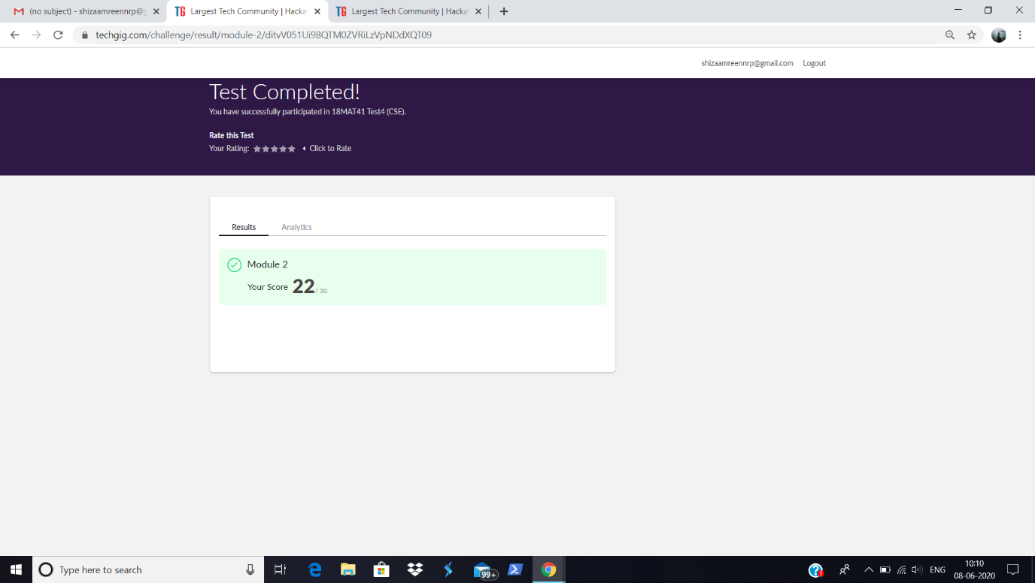

Certification Course Details:

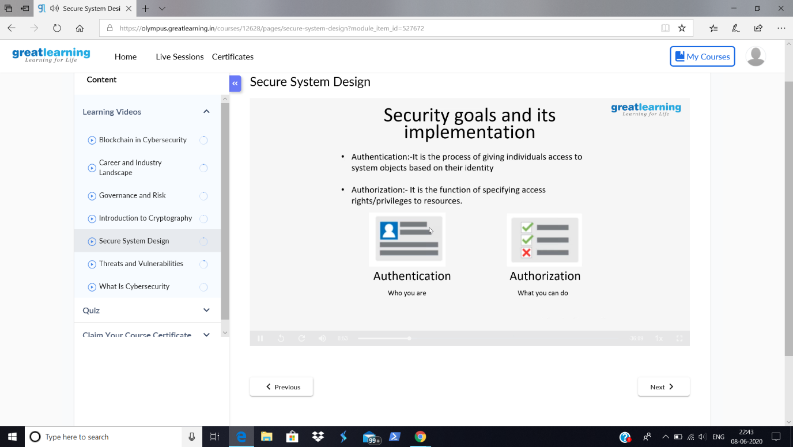

In the course Introduction to Cyber Security, today I have learnt about the security goals and its implementation.

Coding Challenges Details:

**Problem Statement:**

**1.**[**C Program to Generate All the Set Partitions of n Numbers Beginning from 1 and so on**](https://github.com/orgs/alvas-education-foundation/teams/2nd-year/discussions/108)**.**

**2.** [**Write a Java Program to check whether the given matrix is magic square or not**](https://github.com/orgs/alvas-education-foundation/teams/2nd-year/discussions/107)**.**

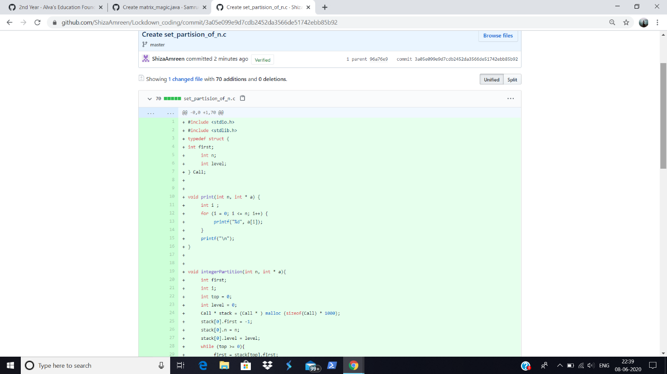

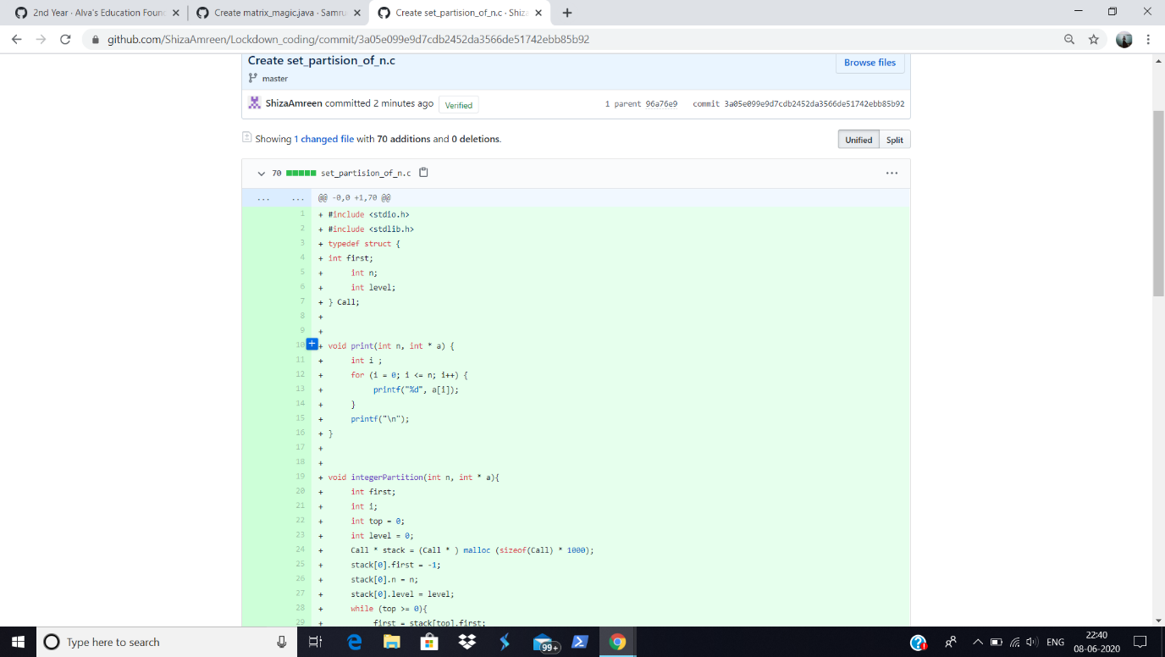

I have written the code for given problem statements and have submitted it in my github repository, Lockdown_Coding.

<https://github.com/ShizaAmreen/Lockdown_coding/commit/6b9dde57f3e9148a65a76e6b6c6db9e3317d2c42>

<https://github.com/ShizaAmreen/Lockdown_coding/commit/3a05e099e9d7cdb2452da3566de51742ebb85b92>